**SensUs 2018 | Team Page**

Welcome!

It is great to hear that you and your team will be participating in SensUs 2018!

Due to the increase of the number of participants, this year the information from the teams will be obtained through this team page. It would be appreciated if you could answer the requested information by filling it in the boxes below.

During the year we might need more information from you and your team than currently asked for in this document. If this is the case, we will send you a request to update your team page.

Should any changes occur within your team or changes in contact information, ensure that this is implemented in the team page to prevent miscommunication.

The information in this document is kept private except for information indicated by an asterisk (*). This information may be used for purposes such as team information on the SensUs website.

If you experience any difficulties or have any questions, do not hesitate to contact me via [contact@senus.org](mailto:contact@senus.org).

With kind regards,

Henriëtte Eijking (secretary)

**Table of Contents**  
  
Team name 3

Contact person 3

Professor / Supervisor 3

Coach / Co-Guide / Co-Supervisor 4

Team Participants 5

Team description * 16

Team Picture * 17

**RWTH Aachen**

Germany

# **Team name**

|  |
| --- |
| **AIXSense** |

# **Contact person**

Second name, initials, first name:

|  |
| --- |
| Palacios, Paula |

Email address:

|  |
| --- |
| paula.palacios@rwth-aachen.de |

Gmail email address:

|  |
| --- |
| paulapalacios21@gmail.com |

Phone number:

|  |
| --- |
| +34 678875419 |

Skype name:

|  |
| --- |
| Paula Palacios |

# **Professor / Supervisor**

Second name, initials, first name:

|  |
| --- |
| Ingebrandt, Sven |

Email address:

|  |
| --- |
| ingebrandt@iwe1.rwth-aachen.de |

Gmail email address:

|  |
| --- |
|  |

Skype name:

|  |
| --- |
| ingebrandts |

# **Coach / Co-Guide / Co-Supervisor**

Second name, initials, first name:

|  |
| --- |
|  |

Email address:

|  |
| --- |
|  |

Gmail email address:

|  |
| --- |
|  |

Phone number:

|  |
| --- |
|  |

Skype name:

|  |
| --- |
|  |

# **Team Participants**

**Team member 1**

Profile picture:

|  |
| --- |
|  |

Second name, initials, first name:

|  |
| --- |
|  |

Gmail email address:

|  |
| --- |
|  |

Phone number:

|  |
| --- |
|  |

Study :

|  |
| --- |
| Education program: BSc, MSc, or PhD  In case of BSc or MSc program: Specify your expected date of graduation: ...  In case of PhD program: Give the date at which you have received your BSc degree: ... |

**Team member 2**

Profile picture:

|  |
| --- |
|  |

Second name, initials, first name:

|  |
| --- |
| Mohajerani, Seyedparham |

Gmail email address:

|  |
| --- |
| sp.mohajerani@gmail.com |

Phone number:

|  |
| --- |
| +49-17621121304 |

Study :

|  |
| --- |
| Education program: MSc Micro and Nanoelectronics RWTH Aachen. Expected Graduation Date: July 2019 |

**Team member 3**

Profile picture:

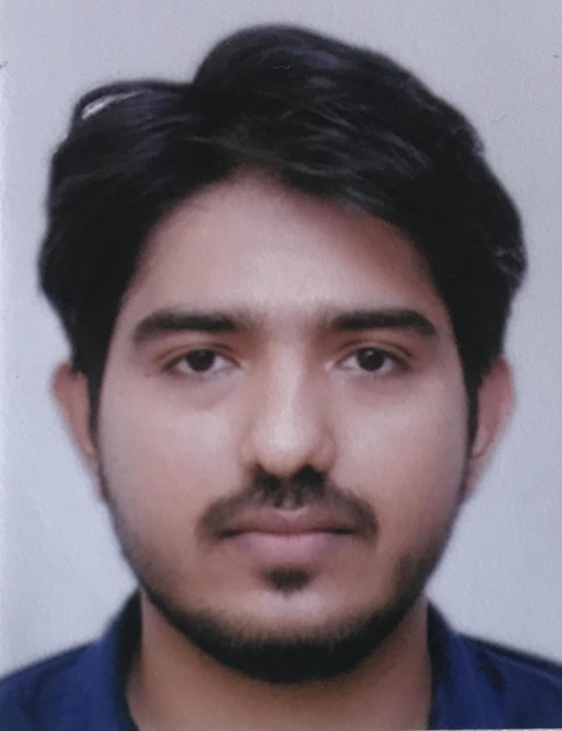

Second name, initials, first name:

|  |
| --- |
| Suranglikar, Mohit |

Gmail email address:

|  |
| --- |
| mohitsuranglikar@gmail.com |

Phone number:

|  |
| --- |
| +49 17673906327 |

Study :

|  |
| --- |
| Education program: MSc (Micro and Nanoelectronics)  Expected Date of Graduation: July 2019 |

**Team member 4**

Profile picture:

|  |
| --- |
|  |

Second name, initials, first name:

|  |
| --- |
| Palacios, Paula |

Gmail email address:

|  |
| --- |
| paulapalacios21@gmail.com |

Phone number

|  |
| --- |
| +34678875419 |

Study :

|  |
| --- |
| Education program: MSc  Expected graduation: 2018 |

**Team member 5**

Profile picture:

|  |
| --- |
|  |

Second name, initials, first name:

|  |
| --- |
|  |

Gmail email address:

|  |
| --- |
|  |

Phone number:

|  |
| --- |
|  |

Study :

|  |
| --- |
| Education program: BSc, MSc, or PhD  In case of BSc or MSc program: Specify your expected date of graduation: ...  In case of PhD program: Give the date at which you have received your BSc degree: ... |

**Team member 6**

Profile picture:

|  |
| --- |
|  |

Second name, initials, first name:

|  |
| --- |
|  |

Gmail email address:

|  |
| --- |
|  |

Phone number:

|  |
| --- |
|  |

Study :

|  |
| --- |
| Education program: BSc, MSc, or PhD  In case of BSc or MSc program: Specify your expected date of graduation: ...  In case of PhD program: Give the date at which you have received your BSc degree: ... |

**Team member 7**

Profile picture:

|  |
| --- |
|  |

Second name, initials, first name:

|  |
| --- |
|  |

Gmail email address:

|  |
| --- |
|  |

Phone number:

|  |
| --- |
|  |

Study :

|  |
| --- |
| Education program: BSc, MSc, or PhD  In case of BSc or MSc program: Specify your expected date of graduation: ...  In case of PhD program: Give the date at which you have received your BSc degree: ... |

**Team member 8**

Profile picture:

|  |
| --- |
|  |

Second name, initials, first name:

|  |
| --- |
|  |

Gmail email address:

|  |
| --- |
|  |

Phone number:

|  |
| --- |
|  |

Study :

|  |
| --- |
| Education program: BSc, MSc, or PhD  In case of BSc or MSc program: Specify your expected date of graduation: ...  In case of PhD program: Give the date at which you have received your BSc degree: ... |

**Team member 9**

Profile picture:

|  |
| --- |
|  |

Second name, initials, first name:

|  |
| --- |
|  |

Gmail email address:

|  |
| --- |
|  |

Phone number:

|  |
| --- |
|  |

Study :

|  |
| --- |
| Education program: BSc, MSc, or PhD  In case of BSc or MSc program: Specify your expected date of graduation: ...  In case of PhD program: Give the date at which you have received your BSc degree: ... |

**Team member 10**

Profile picture:

|  |
| --- |
|  |

Second name, initials, first name:

|  |
| --- |
|  |

Gmail email address:

|  |
| --- |
|  |

Phone number:

|  |
| --- |
|  |

Study :

|  |
| --- |
| Education program: BSc, MSc, or PhD  In case of BSc or MSc program: Specify your expected date of graduation: ...  In case of PhD program: Give the date at which you have received your BSc degree: ... |

**Team member 11**

Profile picture:

|  |
| --- |
|  |

Second name, initials, first name:

|  |
| --- |
|  |

Gmail email address:

|  |
| --- |
|  |

Phone number:

|  |
| --- |
|  |

Study :

|  |
| --- |
| Education program: BSc, MSc, or PhD  In case of BSc or MSc program: Specify your expected date of graduation: ...  In case of PhD program: Give the date at which you have received your BSc degree: ... |

**Team member 12**

Profile picture:

|  |
| --- |
|  |

Second name, initials, first name:

|  |
| --- |
|  |

Gmail email address:

|  |
| --- |
|  |

Phone number:

|  |
| --- |
|  |

Study :

|  |
| --- |
| Education program: BSc, MSc, or PhD  In case of BSc or MSc program: Specify your expected date of graduation: ...  In case of PhD program: Give the date at which you have received your BSc degree: ... |

**Team member 13**

Profile picture:

|  |
| --- |
|  |

Second name, initials, first name:

|  |
| --- |
|  |

Gmail email address:

|  |
| --- |
|  |

Phone number:

|  |
| --- |
|  |

Study :

|  |
| --- |
| Education program: BSc, MSc, or PhD  In case of BSc or MSc program: Specify your expected date of graduation: ...  In case of PhD program: Give the date at which you have received your BSc degree: ... |

**Team member 14**

Profile picture:

|  |
| --- |
|  |

Second name, initials, first name:

|  |
| --- |
|  |

Gmail email address:

|  |
| --- |
|  |

Phone number:

|  |
| --- |
|  |

Study :

|  |
| --- |
| Education program: BSc, MSc, or PhD  In case of BSc or MSc program: Specify your expected date of graduation: ...  In case of PhD program: Give the date at which you have received your BSc degree: ... |

**Team member 15**

Profile picture:

|  |
| --- |
|  |

Second name, initials, first name:

|  |
| --- |
|  |

Gmail email address:

|  |
| --- |
|  |

Phone number:

|  |
| --- |
|  |

Study :

|  |
| --- |
| Education program: BSc, MSc, or PhD  In case of BSc or MSc program: Specify your expected date of graduation: ...  In case of PhD program: Give the date at which you have received your BSc degree: ... |

# **Team description \***

Please write a short description of your team. Think about your team composition, goals, motives and maybe even your dreams. Use around 250 words.   
The deadline for your final version of you team description is **16 December 2017**.

|  |
| --- |
|  |

# 

# 

# **Team Picture \***

In your team folder you can find, besides the Team Page map, a folder with the name: “Upload here your Team Picture”. You need to upload your Team Picture before **20 December 2017**.

Keep in mind that your team picture will be uploaded on the website and therefore has to be of high quality. You can change your Team Picture at any time during the competition. If you upload a new picture, please send an email to: contact@sensus.org